Activation Functions in ANN

Lesson Introduction
- Activation functions determine the output of a neuron based on its input.
- They introduce non-linearity, allowing ANNs to learn complex patterns.

Mini Agenda
- Sigmoid
- Tanh
- ReLU
- Leaky ReLU
- Softmax
- When & Why to use each

Real-World Hook
- Imagine a spam filter for emails.
- Without activation functions, the network can only learn linear relationships, like “if subject contains ‘free’, mark as spam”.
- Activation functions allow the network to detect complex patterns, like combinations of keywords, sender reputation, and email structure.

Introduce Topic as a Solution
- Activation functions decide whether a neuron should fire.
- They enable deep networks to model non-linear relationships, which is essential for tasks like image recognition, NLP, and speech recognition.

Theory Explanation

1. Sigmoid
- What: Maps input to a value between 0 and 1.
- Formula:
σ(x)=11+e−x\sigma(x) = \frac{1}{1 + e^{-x}}
- Why: Good for probabilities and binary classification.
- Advantages: Smooth gradient, output interpretable as probability.
- Disadvantages: Vanishing gradient for large |x|, slow convergence.
- When to Use: Binary classification at output layer.
- When NOT to Use: Hidden layers in deep networks (gradient vanishing problem).
- Example (Python):
import numpy as np
def sigmoid(x):
return 1 / (1 + np.exp(-x))

2. Tanh
- What: Maps input to [-1, 1].
- Formula:
tanh⁡(x)=ex−e−xex+e−x\tanh(x) = \frac{e^x - e^{-x}}{e^x + e^{-x}}
- Why: Zero-centered output, better for optimization than sigmoid.
- Advantages: Smooth gradient, zero-centered.
- Disadvantages: Still suffers from vanishing gradient.
- When to Use: Hidden layers when data is centered around 0.
- Example:
def tanh(x):
return np.tanh(x)

3. ReLU (Rectified Linear Unit)
- What: Outputs 0 for negative inputs, linear for positive.
- Formula:
f(x)=max⁡(0,x)f(x) = \max(0, x)
- Why: Efficient, reduces vanishing gradient.
- Advantages: Fast computation, sparse activation.
- Disadvantages: “Dead neurons” if too many inputs ≤ 0.
- When to Use: Most hidden layers in deep networks.
- Example:
def relu(x):
return np.maximum(0, x)

4. Leaky ReLU
- What: Variation of ReLU; allows small gradient when x < 0.
- Formula:
f(x)={xx>00.01xx≤0f(x) = \begin{cases} x & x > 0 \\ 0.01x & x \le 0 \end{cases}
- Why: Solves “dead neuron” problem.
- When to Use: Deep networks where ReLU might die.
- Example:
def leaky_relu(x):
return np.where(x > 0, x, 0.01*x)

5. Softmax
- What: Converts a vector of values into probabilities summing to 1.
- Formula:
σ(z)i=ezi∑jezj\sigma(z)_i = \frac{e^{z_i}}{\sum_{j} e^{z_j}}
- Why: Multi-class classification output layer.
- When to Use: Output layer of classification network with >2 classes.
- Example:
def softmax(x):
exp_x = np.exp(x - np.max(x))
return exp_x / exp_x.sum()

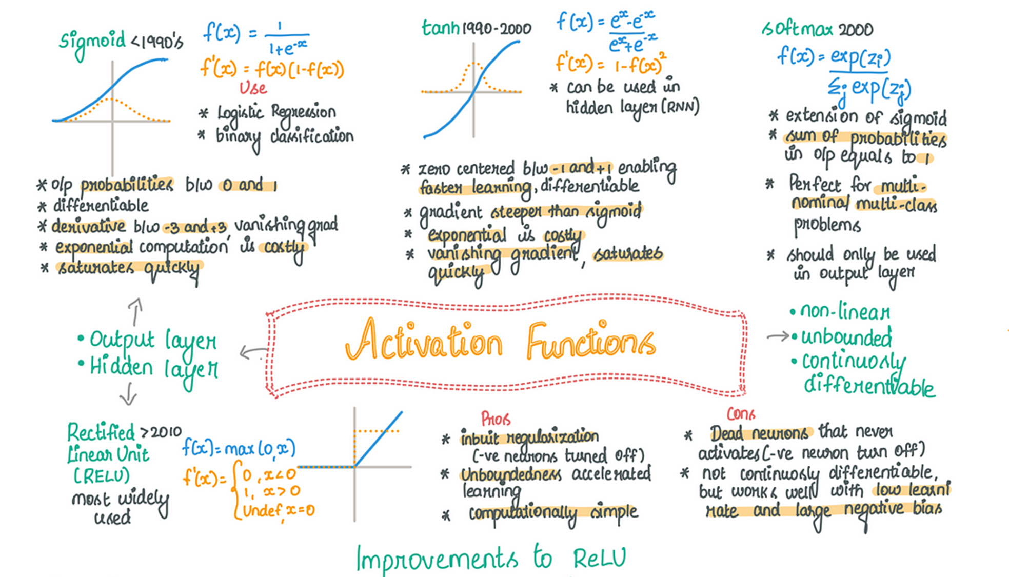

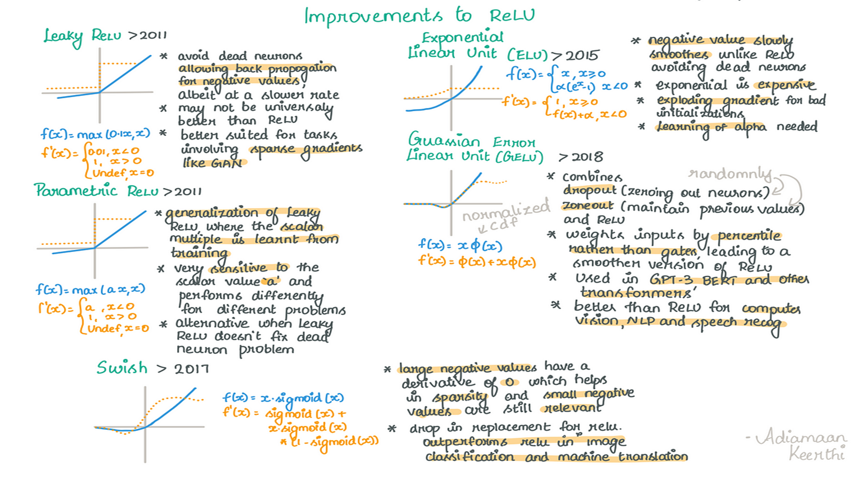

Practical Example
- Dataset: 50 datapoints with inputs x1, x2, target y (binary or multi-class).
- Apply Sigmoid for binary, Softmax for multi-class.

Business Scenario
- Company: Netflix
- Use Case: Recommend movies using ANN with ReLU hidden layers and Softmax output for multi-class genre prediction.

Practice Session
- Compute Sigmoid of x = [0, 2, -2]
- Implement ReLU in Python
- Compare Tanh vs Sigmoid outputs for x = [-3, 0, 3]
- Why use Softmax in multi-class classification?
- Modify ReLU to Leaky ReLU manually and test

Case Study
- Handwritten Digit Classification:
  - Hidden layers: ReLU
  - Output layer: Softmax
  - Predict 0–9 digits from MNIST dataset

Assignments
- Implement all 5 activation functions in NumPy and plot their graphs.

Quiz
- Which activation function outputs [-1,1]?
- Why ReLU is preferred in hidden layers?
- Which function is used in multi-class output?

Resources
- Activation Functions in Deep Learning – Medium
- PyTorch Activation Functions

Interview Questions
Theoretical:
- Difference between ReLU and Leaky ReLU
- Why sigmoid may cause vanishing gradient
- When to use Softmax
Practical:
- Implement Sigmoid in Python
- Implement ReLU in NumPy
- Apply Softmax to a vector [2,1,0.5,3]

If you want, I can now create a Streamlit interface where learners can draw/upload inputs and see outputs for all 5 activation functions live, so it’s interactive.
Do you want me to do that next?

